Test Case: runTestMultipleTimes
Step 1 - Enter username and password and click to button Enter : Credentials Entered
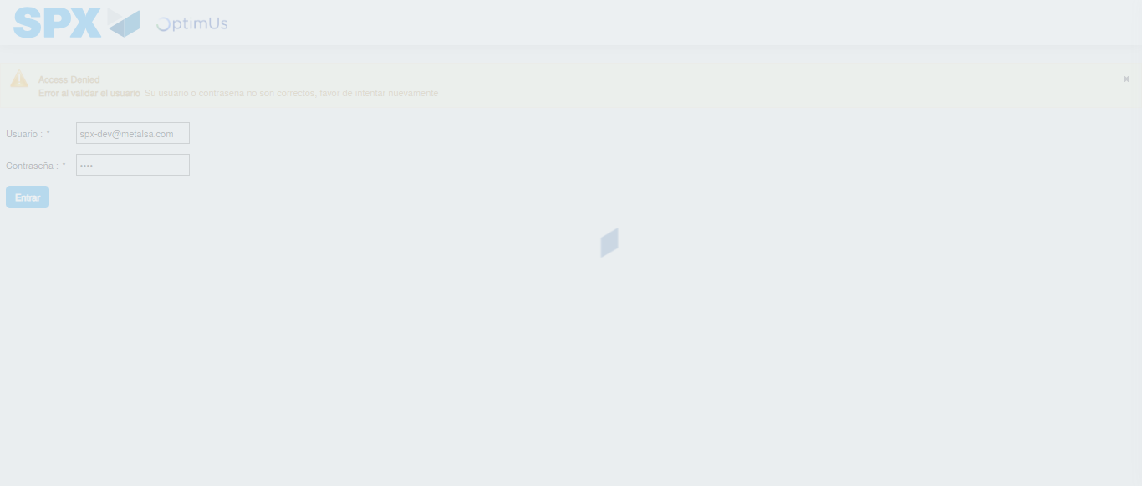Image file-name: QC_Testing-runTestMultipleTimes-nov. 24 2025, 07 43 48 p. m.

Step 2 - Select to UEN and Access to Spot Buy Requisitions : UEN Correctly selected and Correct access
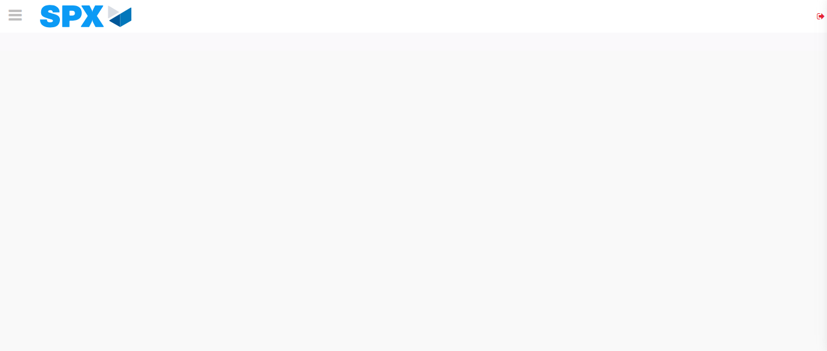Image file-name: QC_Testing-runTestMultipleTimes-nov. 24 2025, 07 43 53 p. m.

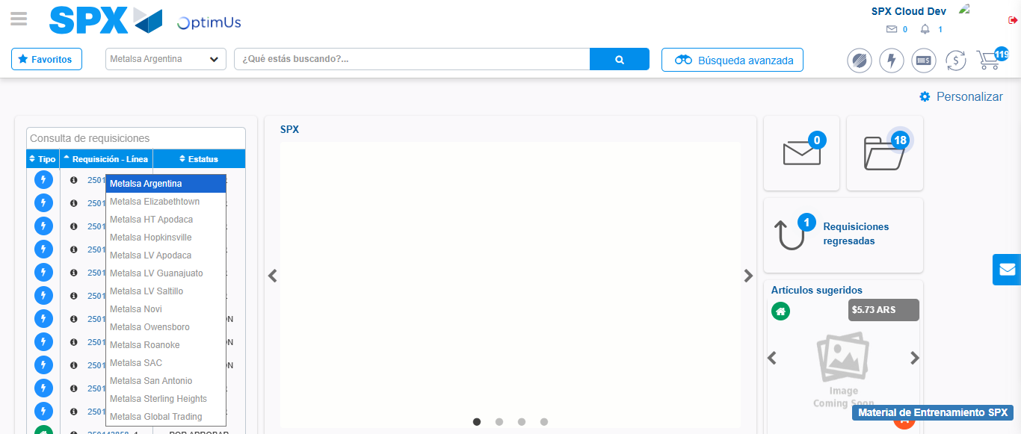Image file-name: QC_Testing-runTestMultipleTimes-nov. 24 2025, 07 43 54 p. m.

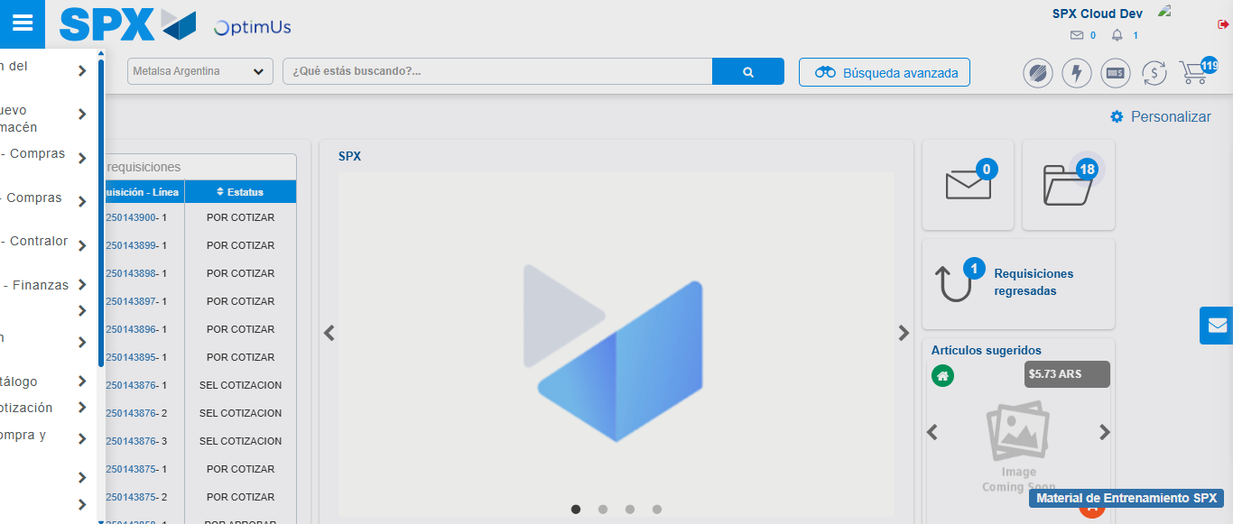Image file-name: QC_Testing-runTestMultipleTimes-nov. 24 2025, 07 43 55 p. m.

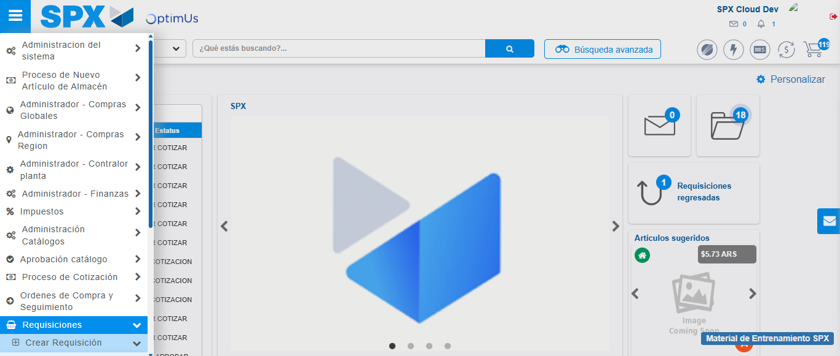Image file-name: QC_Testing-runTestMultipleTimes-nov. 24 2025, 07 43 56 p. m.

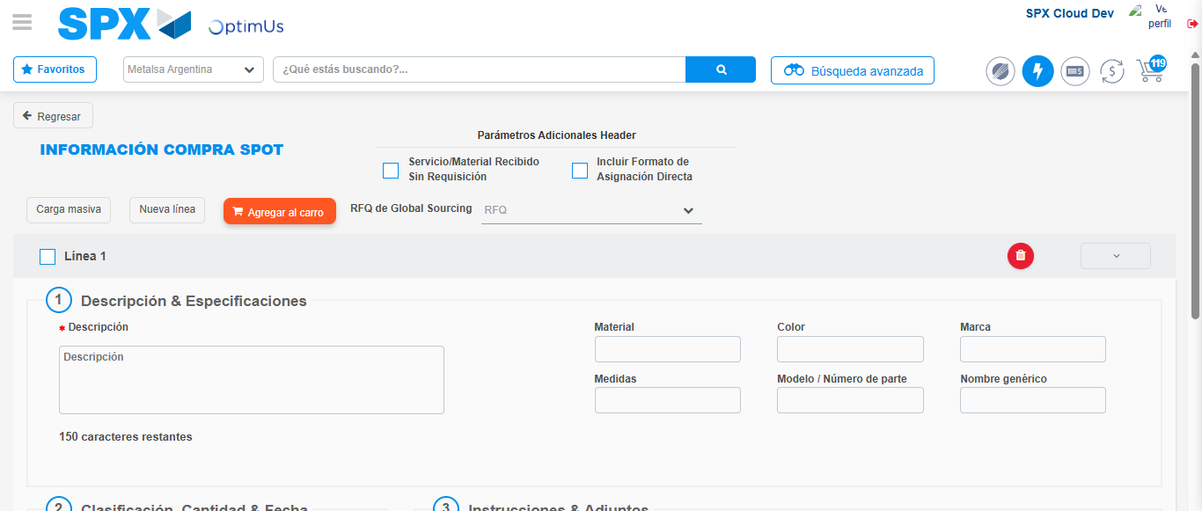Image file-name: QC_Testing-runTestMultipleTimes-nov. 24 2025, 07 43 59 p. m.

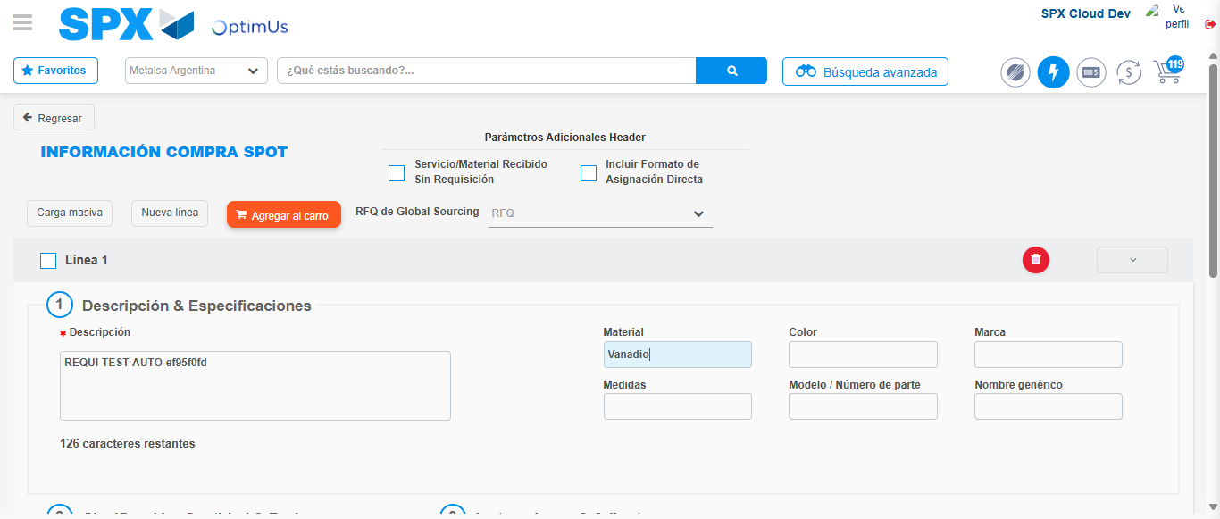Image file-name: QC_Testing-runTestMultipleTimes-nov. 24 2025, 07 44 00 p. m.

Step 3 - Data Capture Spot Buy Requisition : Data captured correctly
Image file-name: QC_Testing-runTestMultipleTimes-nov. 24 2025, 07 44 00 p. m.

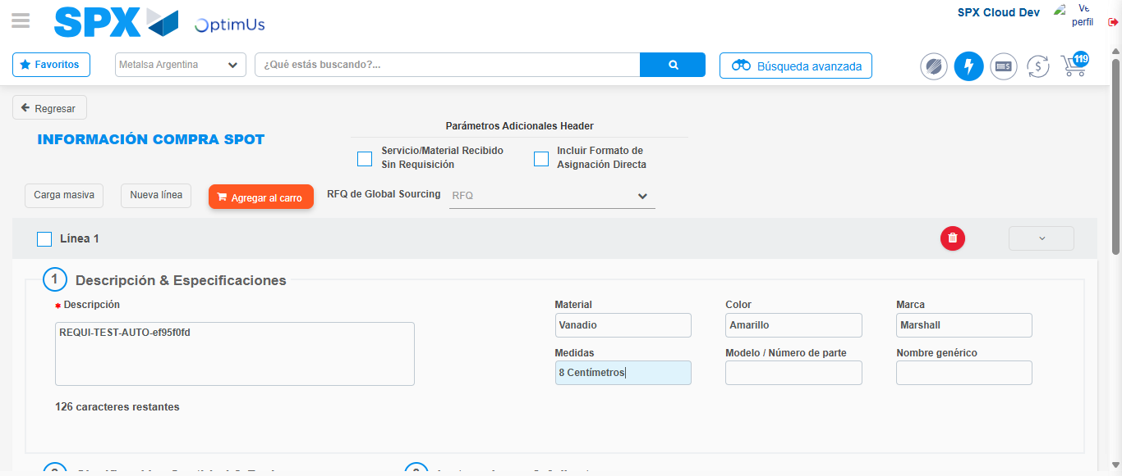Image file-name: QC_Testing-runTestMultipleTimes-nov. 24 2025, 07 44 01 p. m.

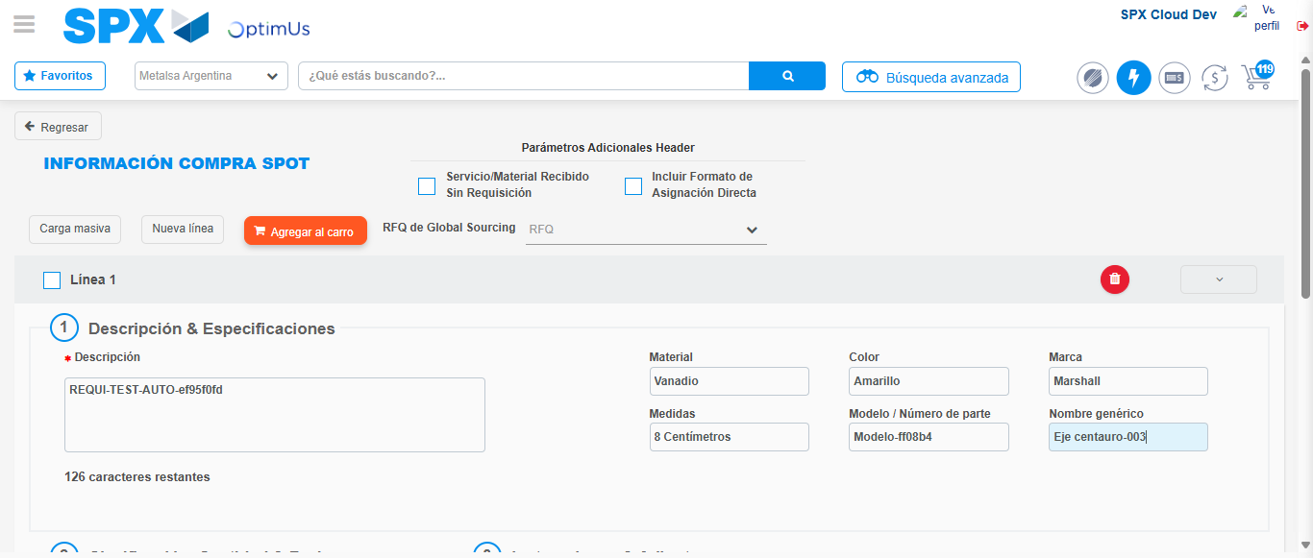Image file-name: QC_Testing-runTestMultipleTimes-nov. 24 2025, 07 44 02 p. m.

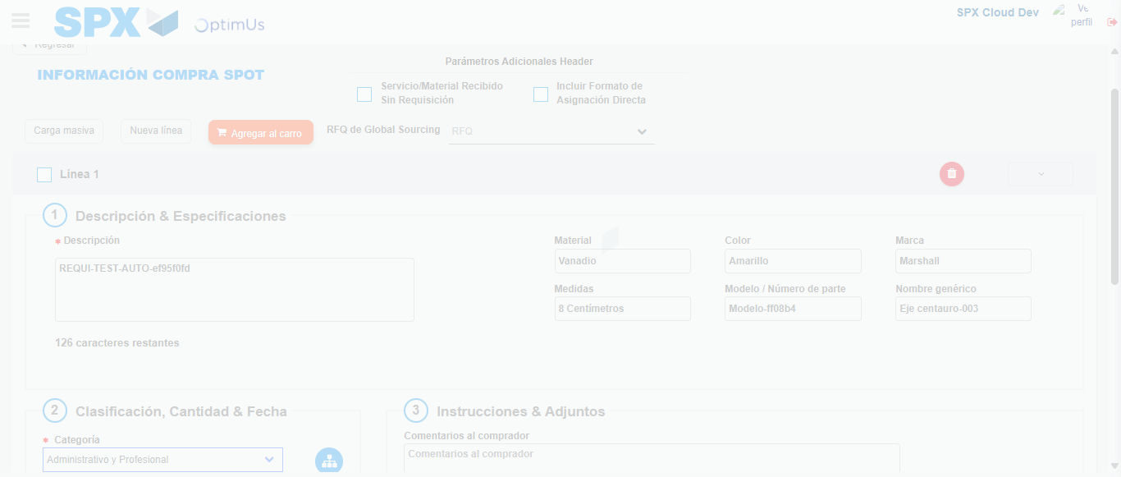Image file-name: QC_Testing-runTestMultipleTimes-nov. 24 2025, 07 44 03 p. m.

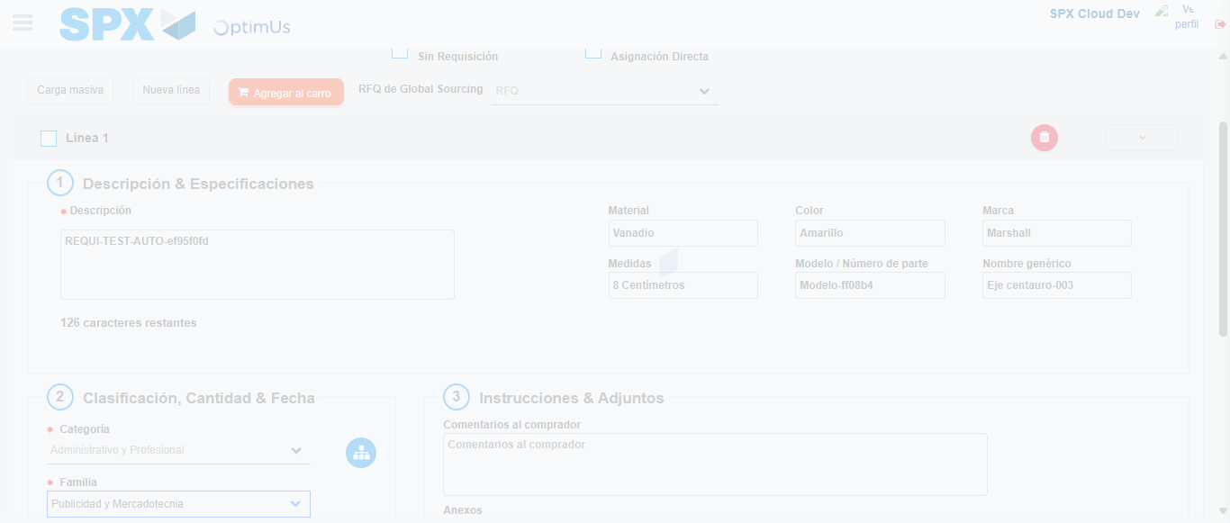Image file-name: QC_Testing-runTestMultipleTimes-nov. 24 2025, 07 44 04 p. m.

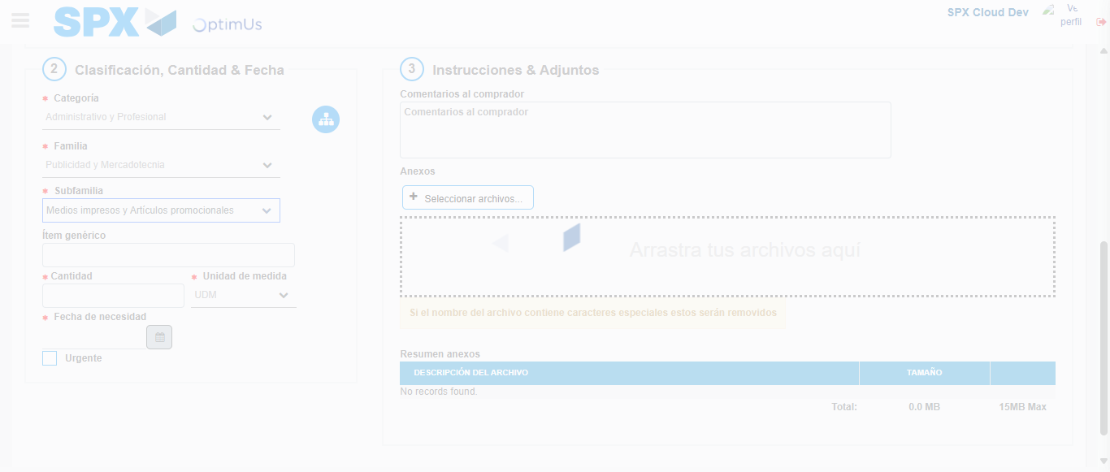Image file-name: QC_Testing-runTestMultipleTimes-nov. 24 2025, 07 44 05 p. m.

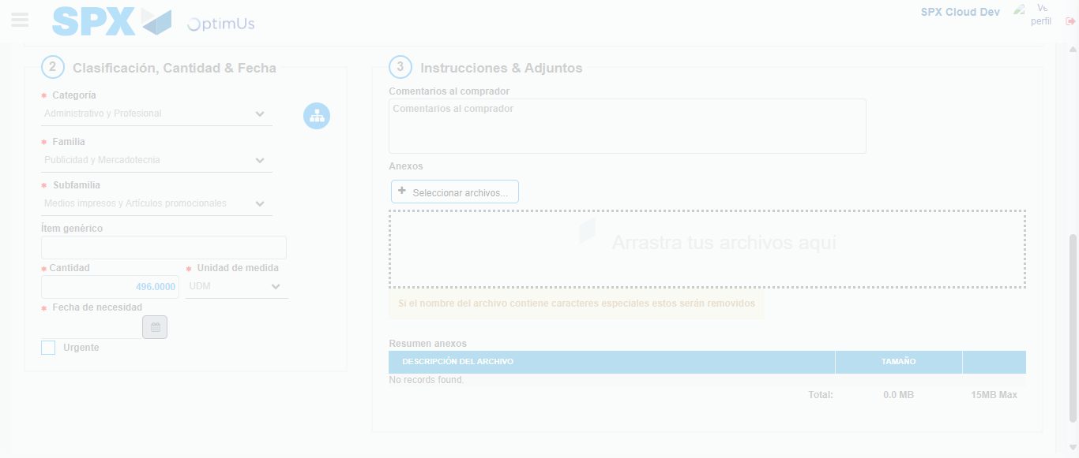Image file-name: QC_Testing-runTestMultipleTimes-nov. 24 2025, 07 44 06 p. m.

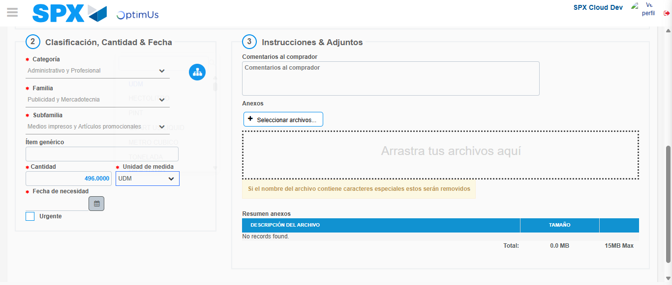Image file-name: QC_Testing-runTestMultipleTimes-nov. 24 2025, 07 44 09 p. m.

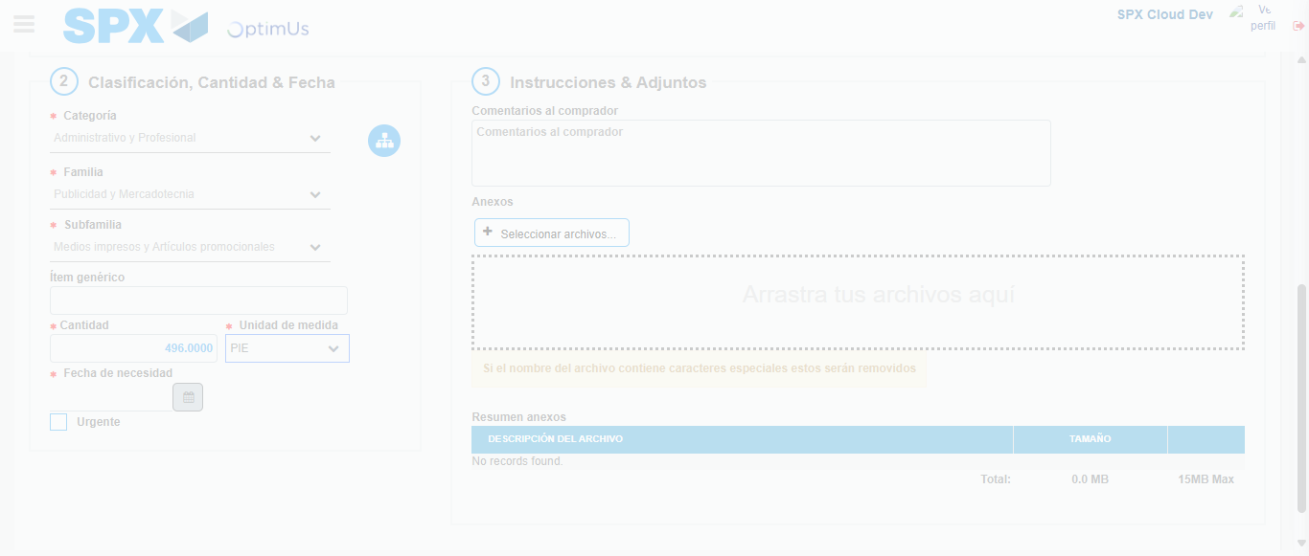Image file-name: QC_Testing-runTestMultipleTimes-nov. 24 2025, 07 44 10 p. m.

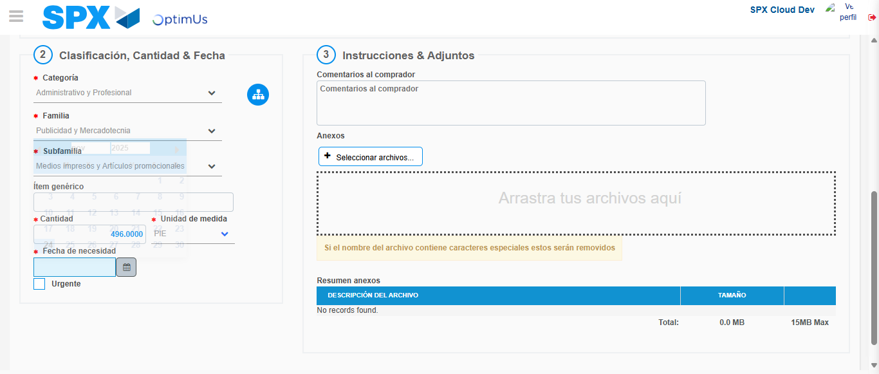Image file-name: QC_Testing-runTestMultipleTimes-nov. 24 2025, 07 44 13 p. m.

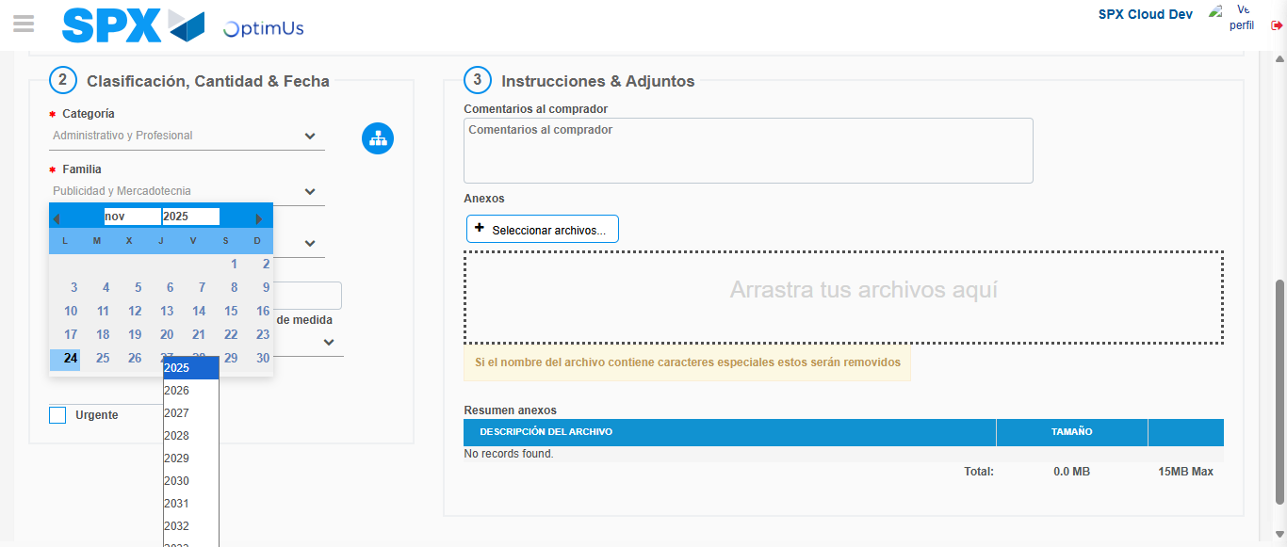Image file-name: QC_Testing-runTestMultipleTimes-nov. 24 2025, 07 44 14 p. m.

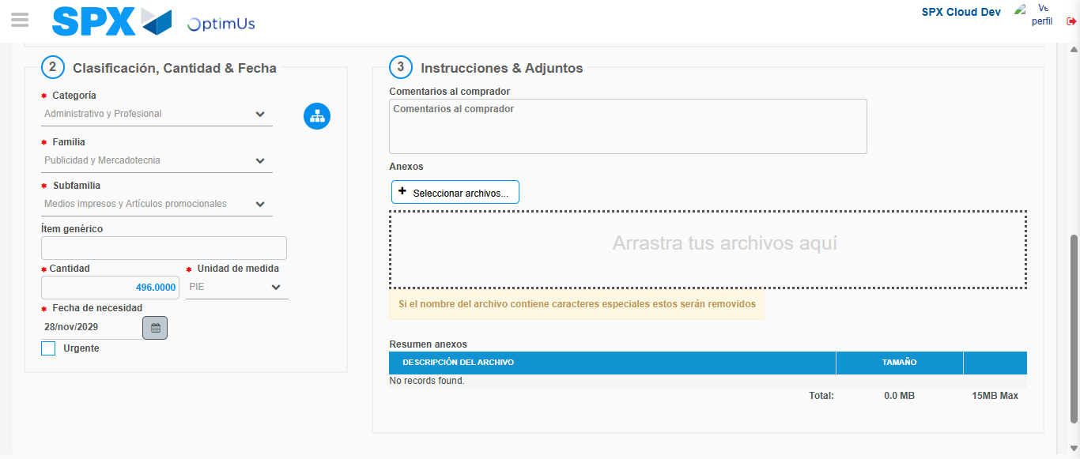Image file-name: QC_Testing-runTestMultipleTimes-nov. 24 2025, 07 44 15 p. m.

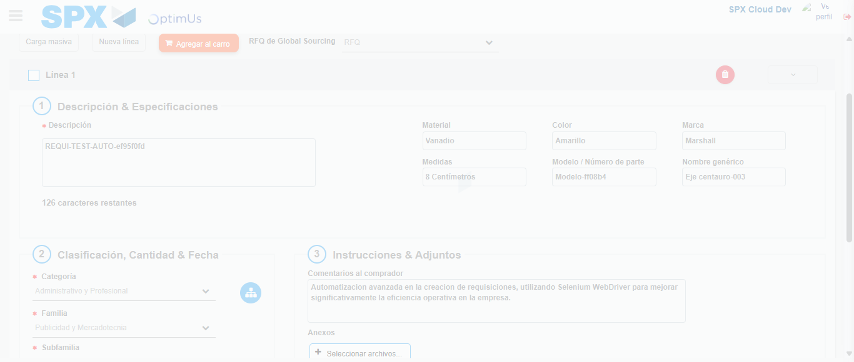Image file-name: QC_Testing-runTestMultipleTimes-nov. 24 2025, 07 44 16 p. m.

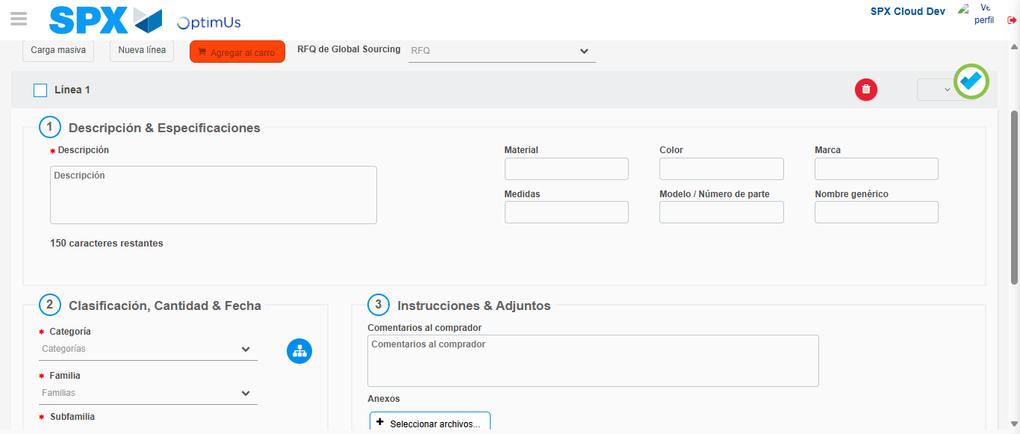Image file-name: QC_Testing-runTestMultipleTimes-nov. 24 2025, 07 44 20 p. m.

Step 4 - Select to Requisition : Requisition Correctly selected
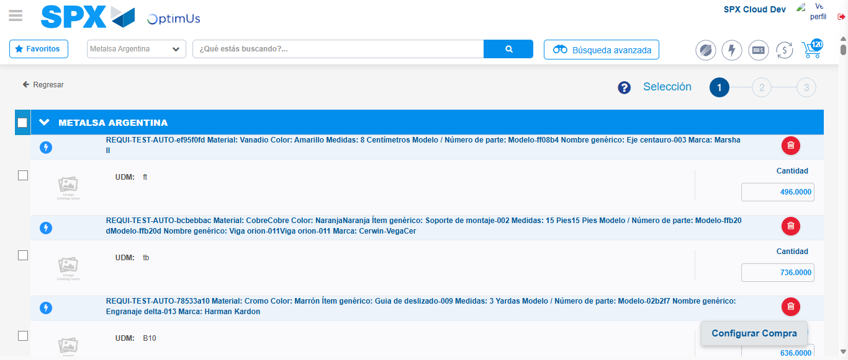Image file-name: QC_Testing-runTestMultipleTimes-nov. 24 2025, 07 44 32 p. m.

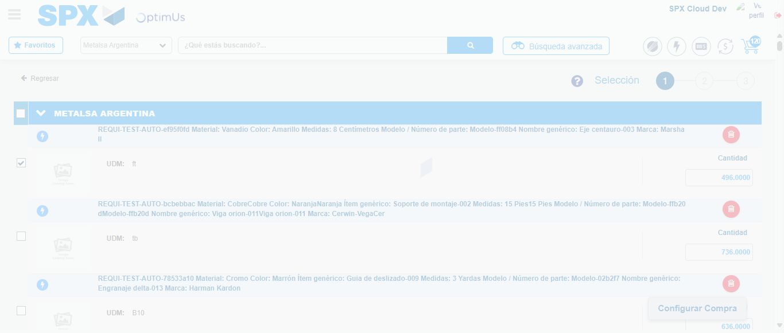Image file-name: QC_Testing-runTestMultipleTimes-nov. 24 2025, 07 44 33 p. m.

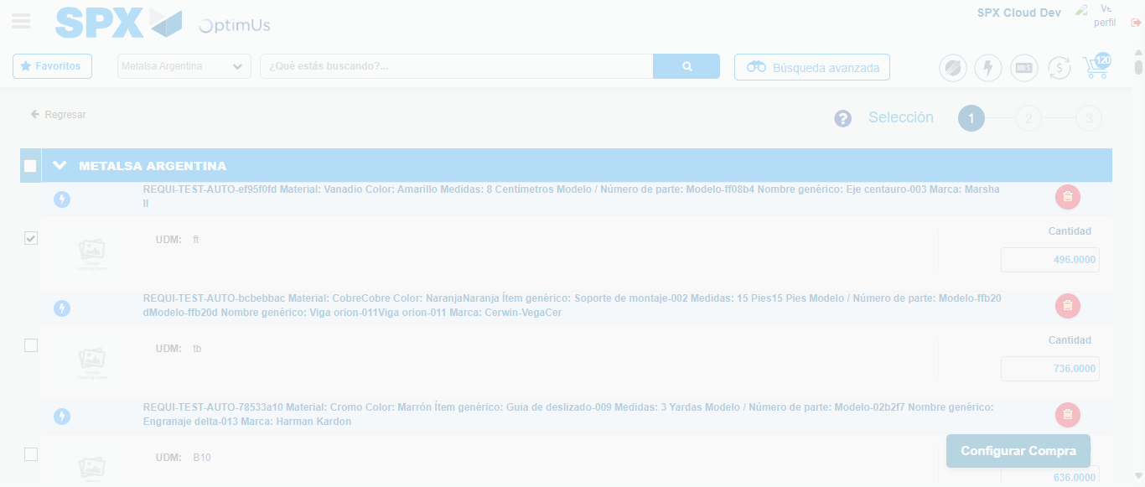Image file-name: QC_Testing-runTestMultipleTimes-nov. 24 2025, 07 44 36 p. m.

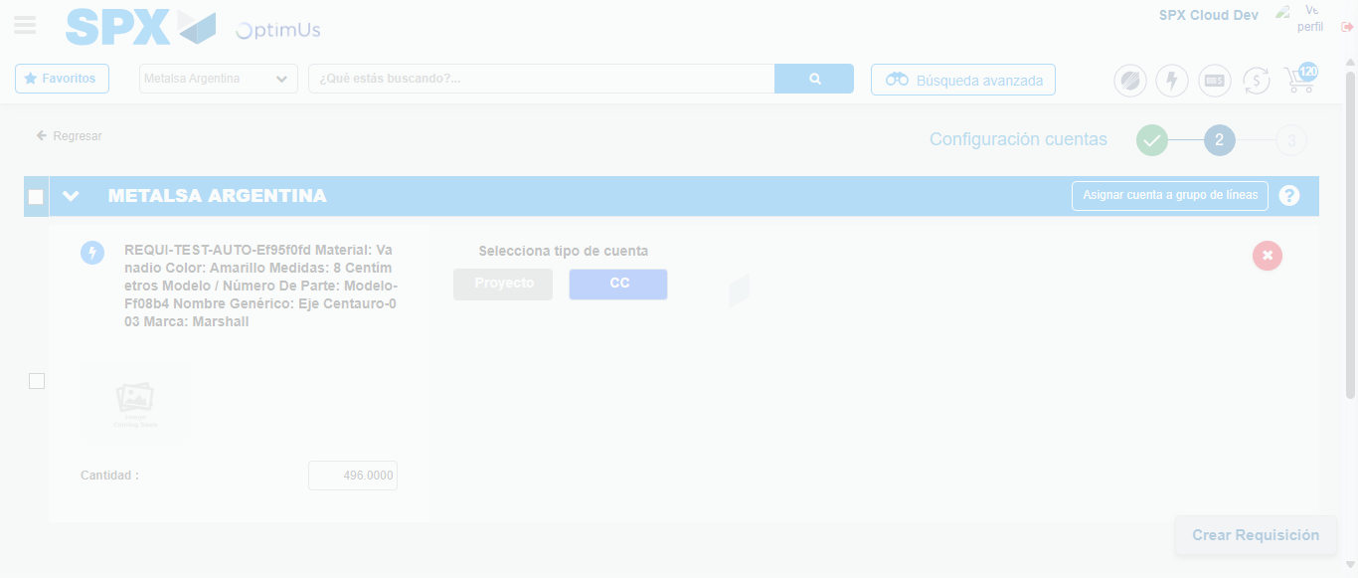Image file-name: QC_Testing-runTestMultipleTimes-nov. 24 2025, 07 44 39 p. m.

Step 5 - Select Type Account For Requisition : Type Account Correctly selected
Image file-name: QC_Testing-runTestMultipleTimes-nov. 24 2025, 07 44 39 p. m.

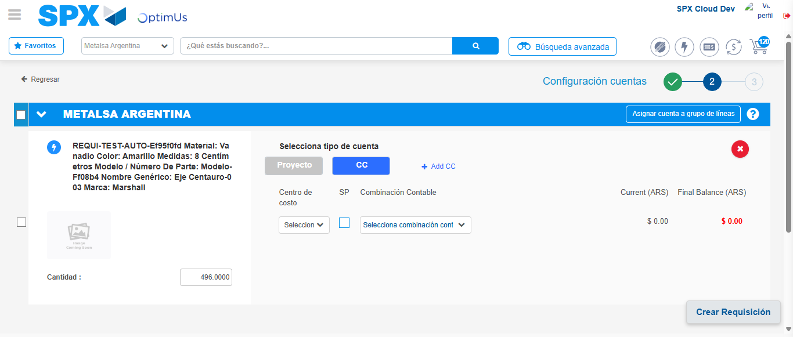Image file-name: QC_Testing-runTestMultipleTimes-nov. 24 2025, 07 44 43 p. m.

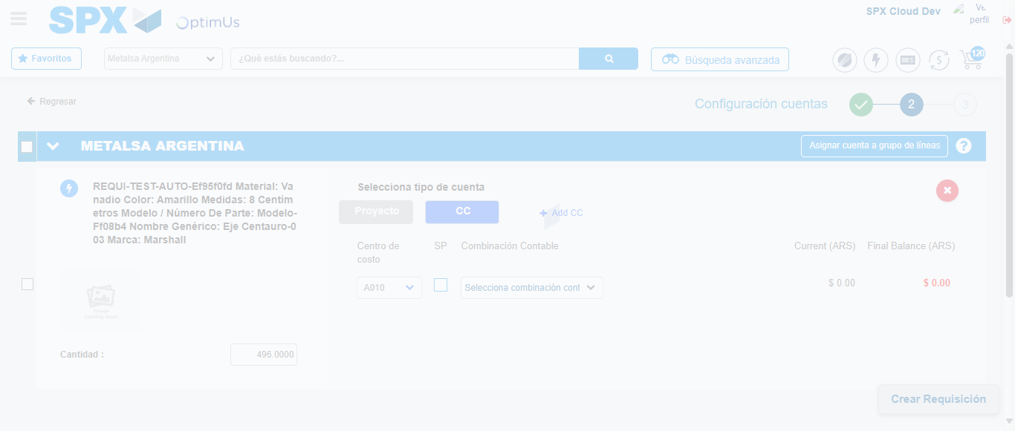Image file-name: QC_Testing-runTestMultipleTimes-nov. 24 2025, 07 44 46 p. m.

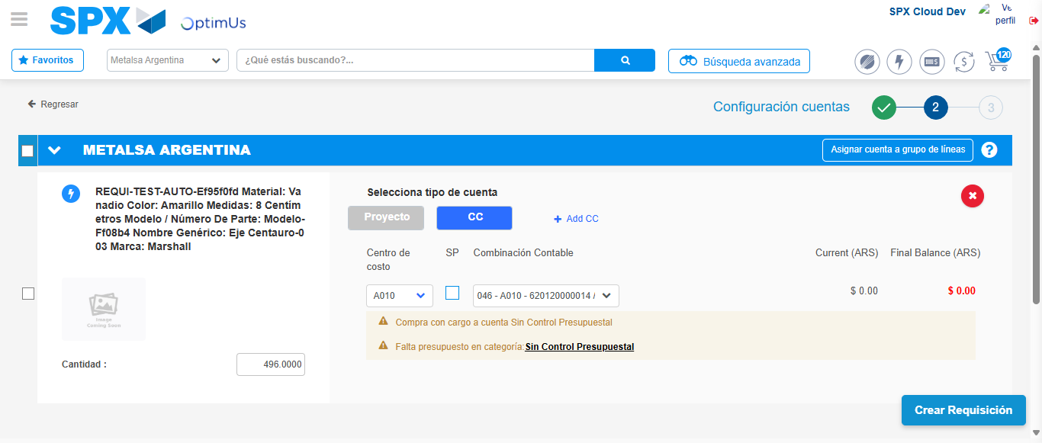Image file-name: QC_Testing-runTestMultipleTimes-nov. 24 2025, 07 44 49 p. m.

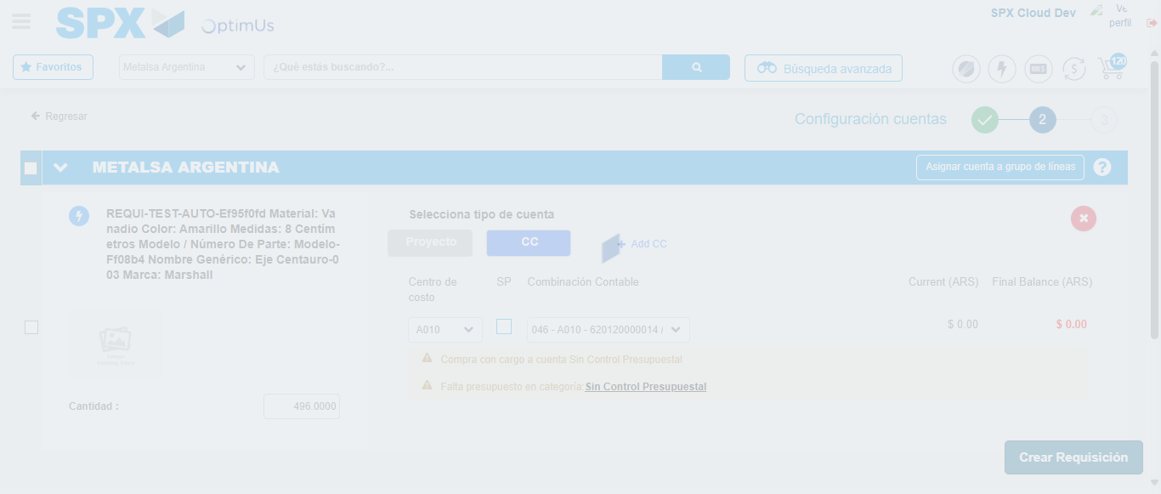Image file-name: QC_Testing-runTestMultipleTimes-nov. 24 2025, 07 44 50 p. m.

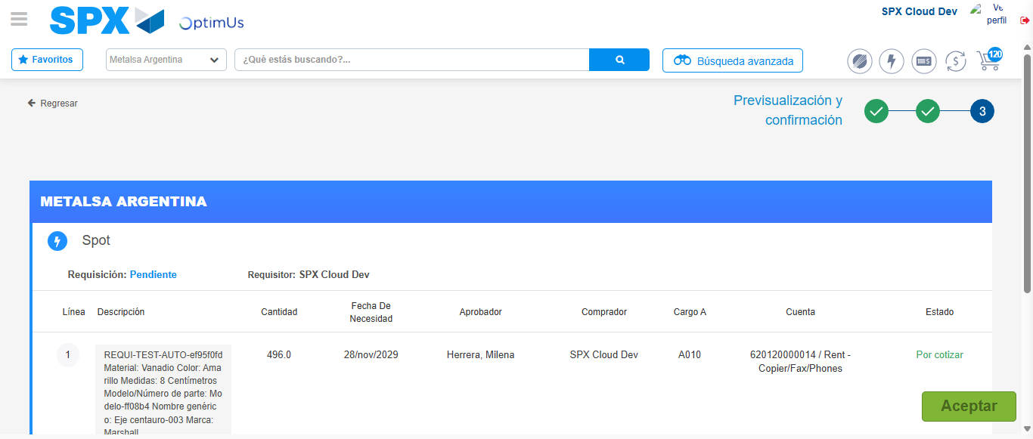Image file-name: QC_Testing-runTestMultipleTimes-nov. 24 2025, 07 44 53 p. m.

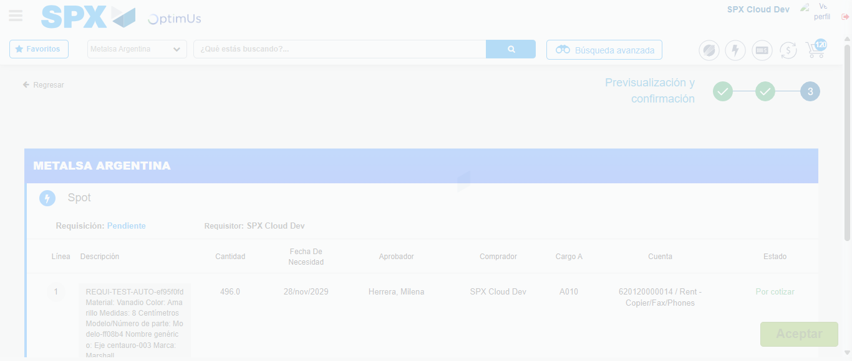Image file-name: QC_Testing-runTestMultipleTimes-nov. 24 2025, 07 44 54 p. m.

Step 6 - Accept to Requisition : Requisition Accepted
Image file-name: QC_Testing-runTestMultipleTimes-nov. 24 2025, 07 44 54 p. m.

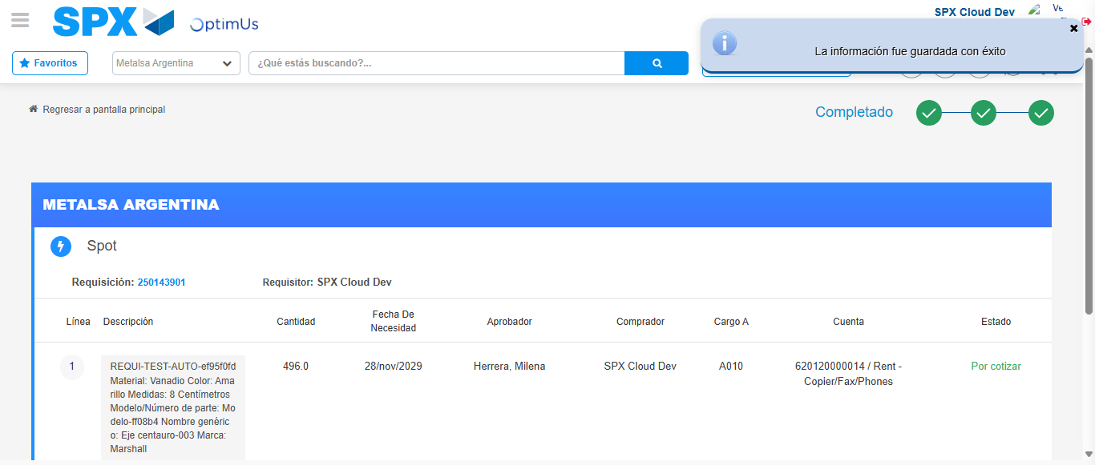Image file-name: QC_Testing-runTestMultipleTimes-nov. 24 2025, 07 44 57 p. m.

